**Lesson #13: Propagation and Link Budgets (part 2)**

**Lesson #13 Learning Objectives:** Upon successfully completing this lesson and the associated homework, students will be able to:

1. Calculate the closest distance that stays within the FCC’s maximum permissible exposure
2. Calculate and plot the effects of multipath interference
3. Measure indoor fading and describe the measured data
   1. **deciBels, dB, and oh my goodness WTF?![1]**

Ok, so yes, these are confusing when you first see them. It took me a while to fully wrap my head around them, but now they are second nature and a dB-scale plot can provide so much more information than a linear plot[2].

A dB is a function that operates on a **unitless** parameter.

dB = 10 log10 (x)

Think of an amplifier gain. *Pout = Pin * G*. The gain is unitless. **BUT** when we talk about **dBm**, we are referenced to **1 mW**. In other words, we take our power quantity and divide by **1 mW**. The result is a unitless value that expresses the value of our initial power in relation to **1 milliWatt**.

Example: If **P = 100 Watts**, then **P / 1mW = 100,000** — a unitless quantity meaning that our power P is 100,000 times larger than **1 milliWatt**.

P (dBm) = 10 log10 (P / 1 mW)

So for **P = 100 Watts**, **P(dBm) =** **+50 dBm**. Likewise, **1 mW** would be expressed as **0 dBm.**

**IMPORTANT**: Be sure you are using **log10** which is “*log base 10*” and not the natural log. Many mathematical software defaults “log” to being the natural log (base e).

At some point in a math class, you had some homework, listened to a lecture and did some problems where you learned about a property of logarithms that

10 log10( 10*n* ) = *n* 10 log10 (10) = 10 *n*

So if we are 100 times greater than **1 mW**, then our power gain is *G = 100 = 102* (*n* = 2 in the above expression) which is expressed as **20 dBm**. If we are 1000 times greater than **1 mW** (**1 Watt**), then our power is expressed as **30 dBm**.

Likewise, if we our power is **0.001 mW = 10-3 mW**, then our power is written as **–30 dBm**.

Another property of logarithms is that multiplication of terms in linear space means we add the logarithms together. This leads to the main purpose of logarithms:



So if we are applying a gain (multiplication), we add the logarithms. This is why in the Friis model we can either work all in linear units and multiply, or we can work in all logarithmic units and add.

Lastly, **deciBels** are for Power quantities. Thus, often times we see something like

20 log10 ( x ) = 10 * log10( x2 )

which is valid for quantities such as voltages (which we square and divide by a unit resistance to convert to a power) or for when we are squaring our term such as with the last term of the Friis model.

* 1. **dBm <—> regular units**

You can now understand how to convert from a power to an logarithmic expression in **dBm**. Now we’ll talk about going to the other way. Logarithms are ways to express *exponents*, and as such we can go from **dB** (logarithmic units) to linear units as follows. This is shown for **dBm**



So by just plugging in the value in **dBm**, we can convert to **mW**. However, how can we convert to **Watts**? Obviously we could just multiply by ***1x103***, but since we’re already dealing with exponents, there’s a trick. To convert from **dBm** to **dBw** (power referenced to **1 W**) we add *30*.



Therefore, to go from **dBm** directly to **Watts**,



So there are your key equations. If you are using the linear version of the Friis model, you will end up with Watts. Therefore, to convert from Watts to dBm, use the following:



* 1. **FCC Maximum Permissible Exposure**

The FCC limits the power that humans can be exposed to (Or rather, has determined what are currently believed to be the safe exposure levels). This is frequency-dependent and measured in mW/cm2  -- a power density! You can look this up on the FCC’s website in Title 47, Section 1.1310

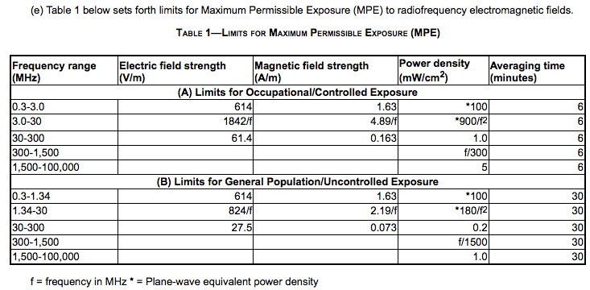

We will be working with **915 MHz**. For this band, the maximum permissible exposure is limited to a power density of ***915/300 = 3.05 mW/cm2***. We have previously seen that we can calculate the power density in **W/m2** using the formula  where **p** is our power density, **Pt** is the transmit power, **Gt** is the gain of the transmitting antenna.

For example: Consider a **+27 dBm** transmitter (**0.5 W**) connected to an antenna with a gain of **8 dBi**. Solving the above equation for ***p = 3.05 mW/cm2***, we must stay at least **0.0907 m** (9.07 cm) away from the transmitting antenna (or about 3.6 inches).

** Calculate the closest range you can be to an antenna with a gain of 10.1 dBi transmitting a 915 MHz signal at a power of -7 dBm. **

* 1. **Multipath interference**

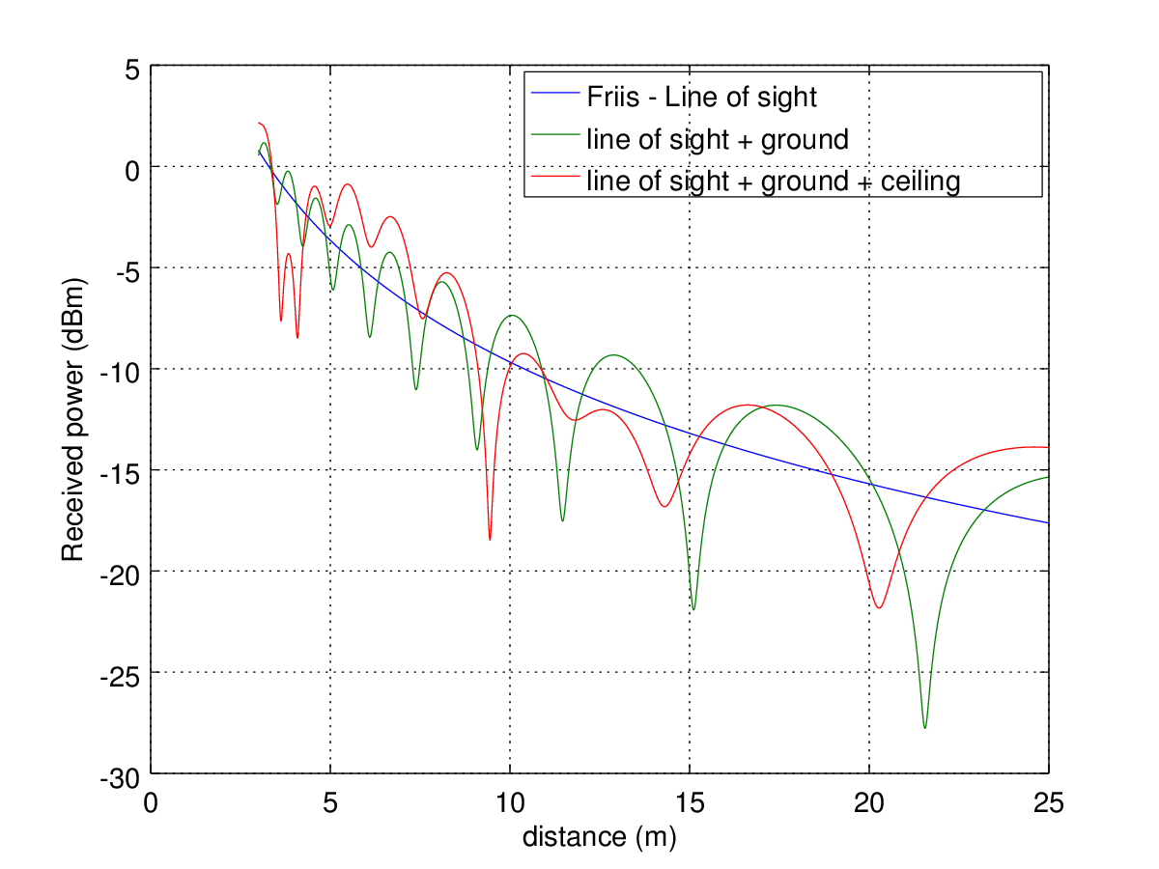Consider an antenna transmitting a **1-Watt**, **915 MHz** signal in a hallway. The line-of-sight power can be modeled using the Friis equation which includes path loss owing to spherical expansion of the wavefront and antenna gains. If we add in a ground bounce we will see combinations of constructive and destructive interference as the two waves interact. If we add in a third path which bounces off of the ceiling, we get even further interferences. The result is a chaotic looking signal with big valleys and a few broad peaks.

This can be see in the plot to the left. The black line models the Friis equation (line of sight only). The blue line includes just the ground and the redline includes both ground and ceiling bounces. As we can see, there are spots where the interference helps us a lot and there are spots when the power takes a big dip. This plot assumes the antennas are 1.5 m off the ground and the ceiling is 4 m above the floor.

To calculate this type of problem, there are a few more equations we need. For a time-varying cosine wave — meaning a wave that varies in time as well as in position — the equation is written as

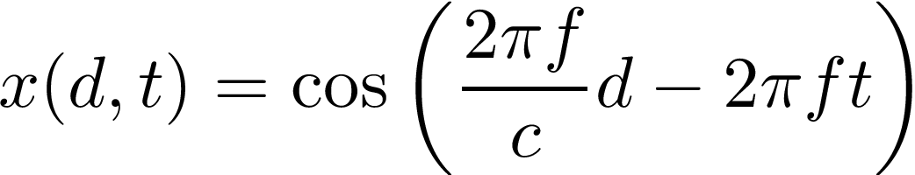

Where *d* is the horizontal distance and *t* is time. Generally we are only concerned about a sinusoid’s value at a certain time. However, depending on where in space we measure a wave, it will have a different value.

To simplify things, we are not going to consider the time-varying portion of a wave and assume a steady state. Meaning, we are assuming that the wave has been traveling for a long time, and we are just going to read the value at time **t=0**.

The phase argument to sign simplifies to 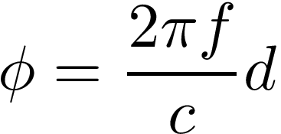. So for a given path length *d* (in meters), we know the phase of the sinusoid. What about the amplitude?

When we derived the Friis equation, the basis was the spherical expansion of the wave. As the wave travels, the power density decreases. The equation for this path loss is 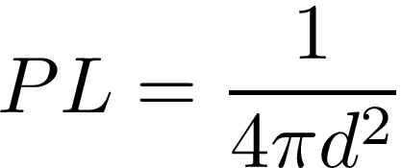. For a single wave we can combine these terms to form a channel model. Channel is just a fancy term to mean the path and interference that a signal has to go through from point A to point B. This could be a cable, or a classroom.

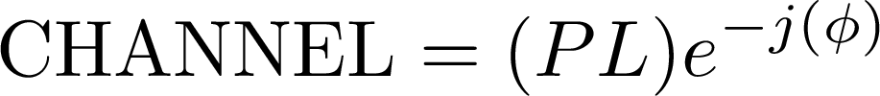

Here wave have used our path loss attenuation value and the received phase value (at time **t=0**). This is for a single path. If we had multiple ways for a signal to reach our receiver, we would just add them up



To actually estimate the received power for a system, this gets combined back with the Friis model.

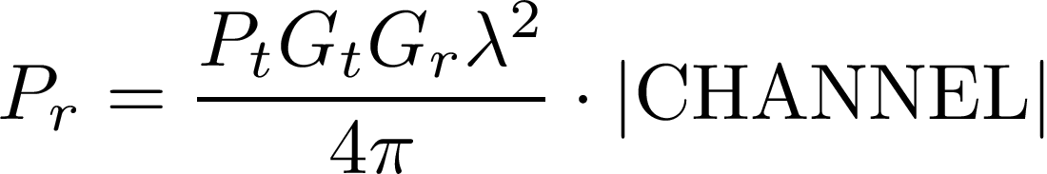

Where we have taken the **absolute value** of the channel and multiplied it with the rest of the Friis equation. So to model the different paths we could take, we need to a) find the distance the wave(s) travel, b) find the phases at time **t=0**, c) find the path losses, d) form the channel, and 3) plug back into the Friis model.

1. An acronym meaning “Where’s the Fire?” commonly uttered by lost firemen when they are very confused and looking for something to do. The more you know.
2. Thanks to Jim Stiles, who has a terrific tutorial posted online from which much of this was lifted. http://www.ittc.ku.edu/~jstiles/622/handouts/dB.pdf